Ironhack  
Data Analytics Bootcamp

August 2021

Anne

26. August 2021

# Week 3 Databases (SQL & MongoDatabase)

EER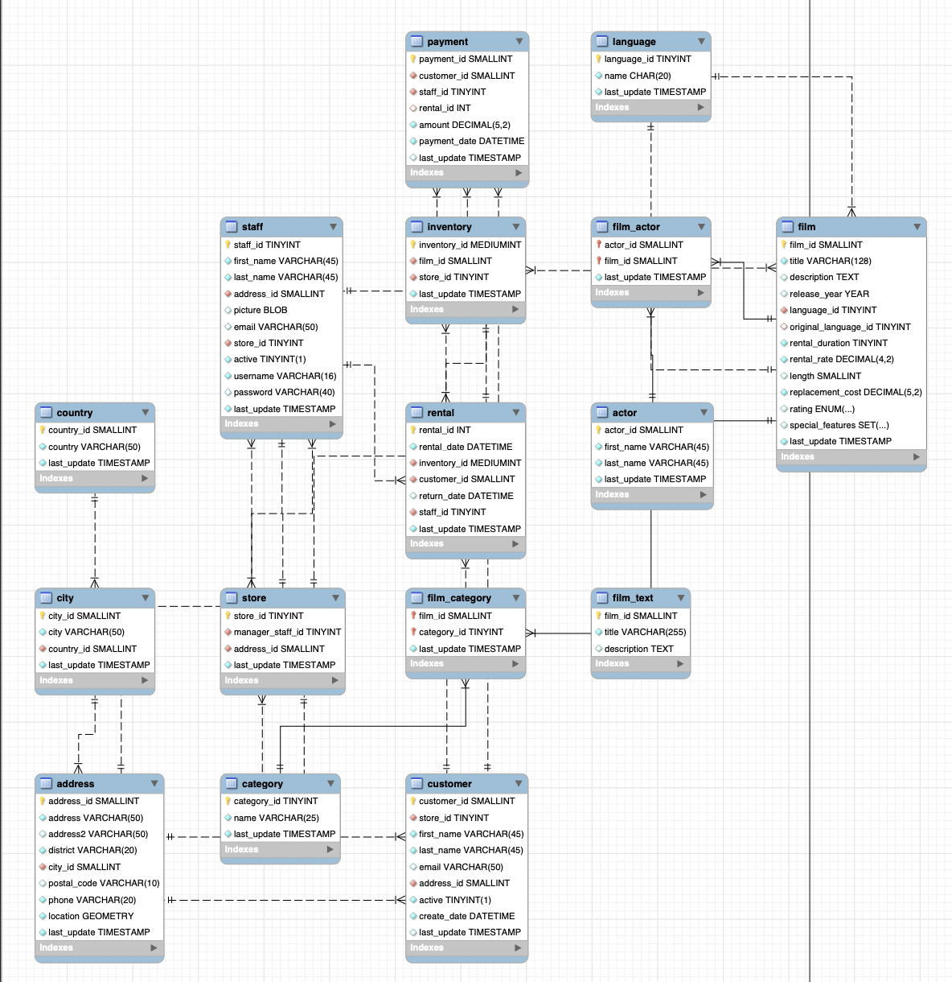

* Overview of tables including primary and foreign keys in order to create joins and subqueries

How to get there? 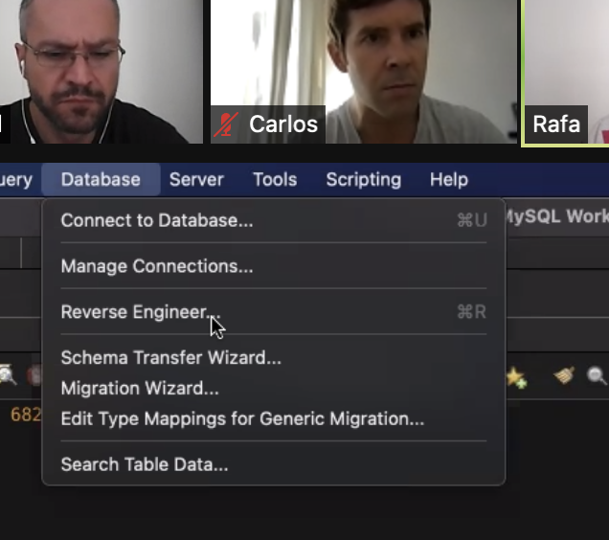

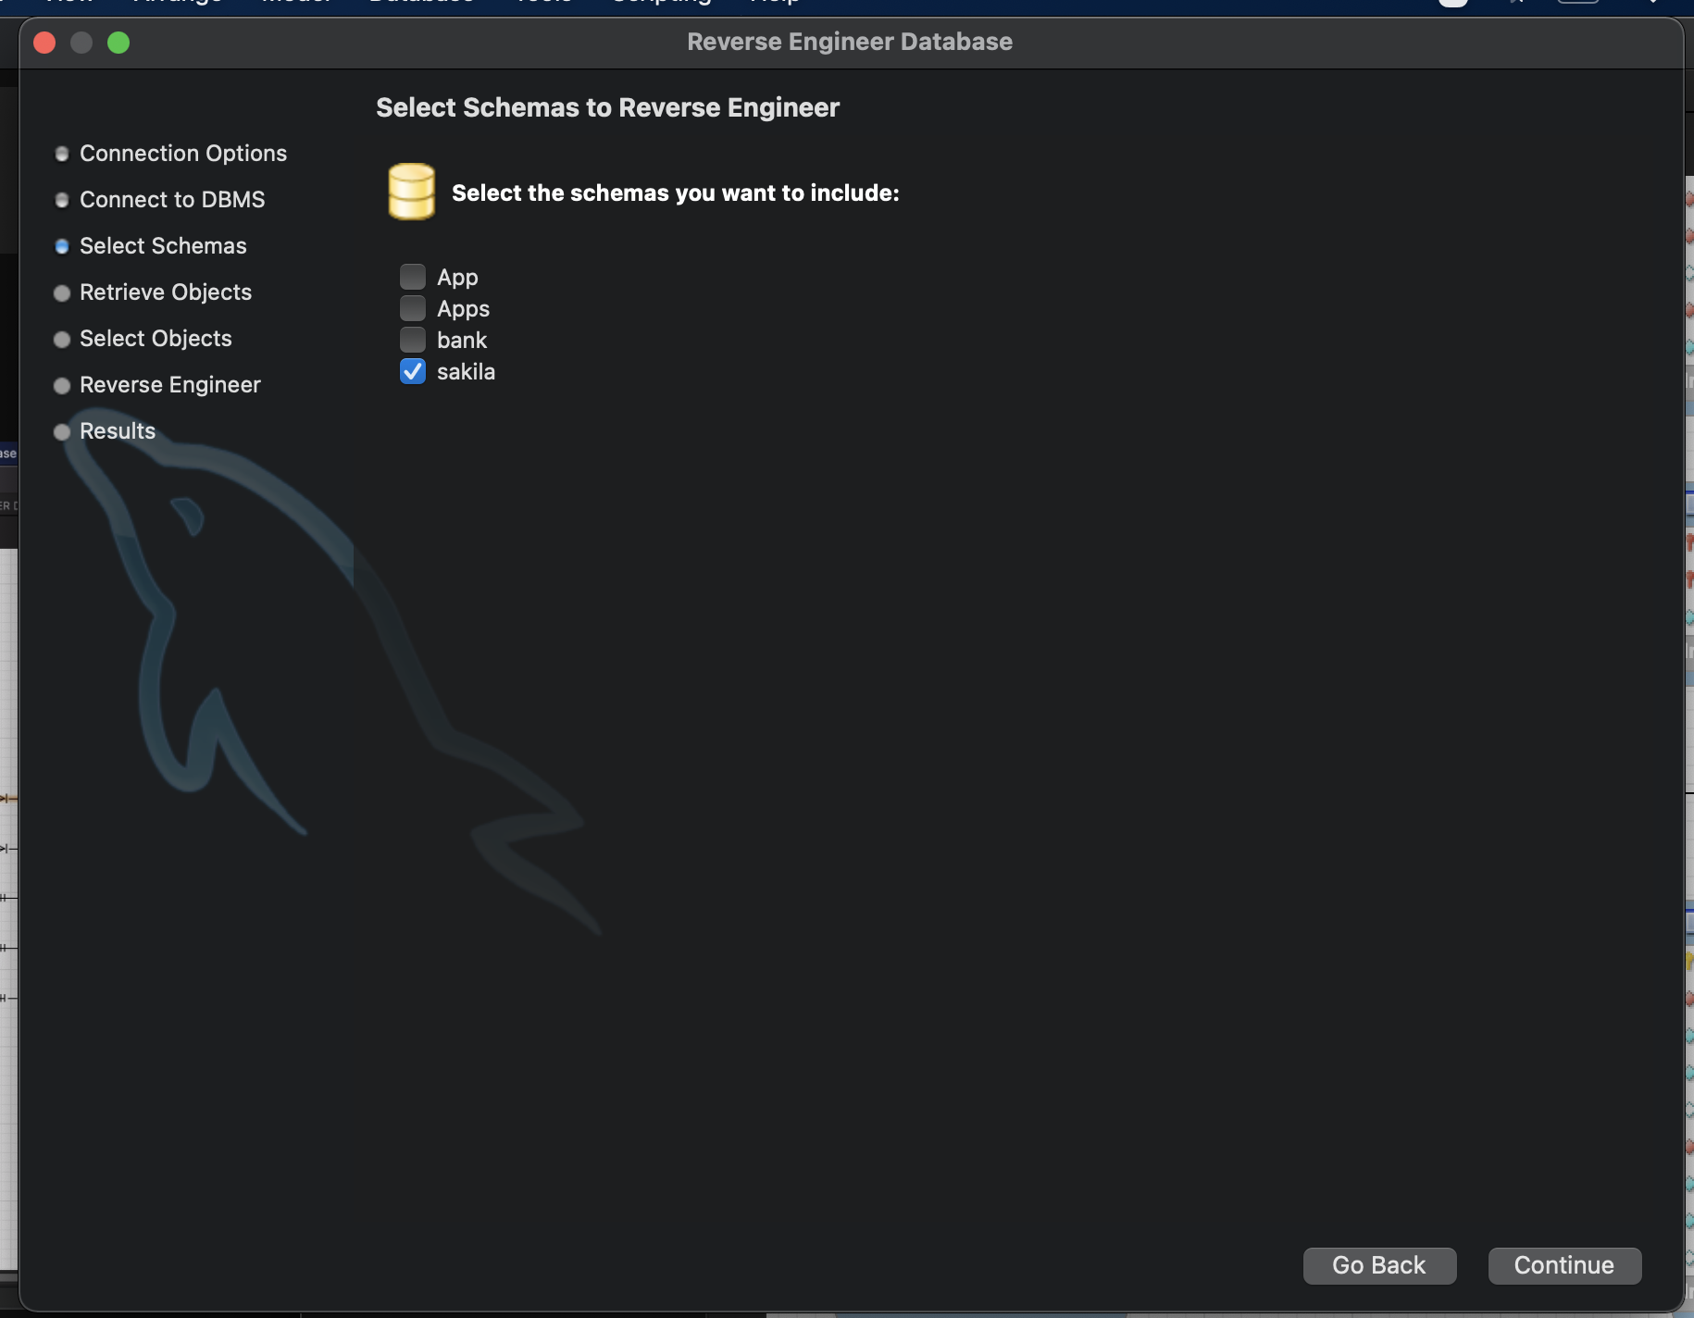

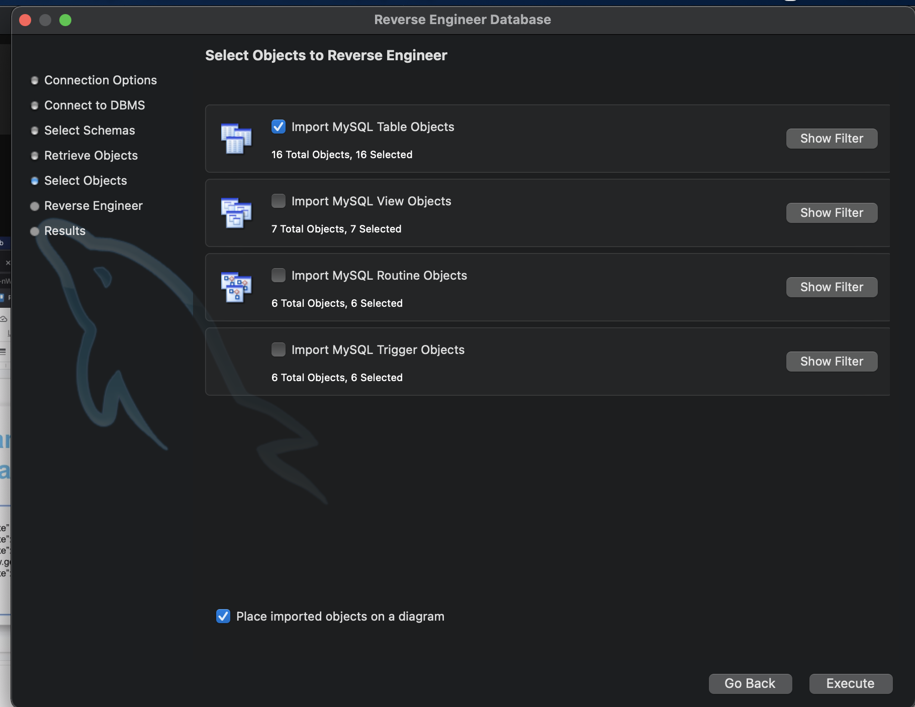

* By double click you can determine variables & their data types 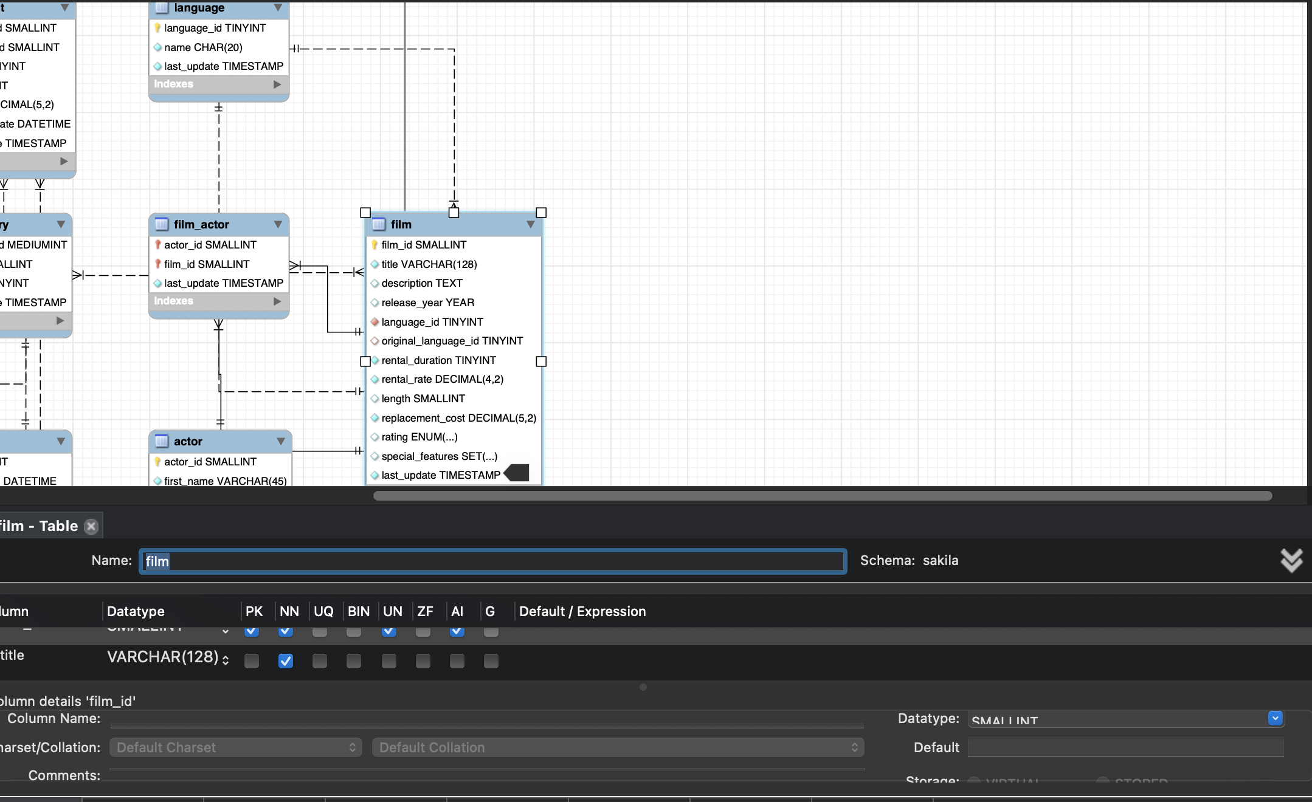
* PK = Primary key
* AI = Automated Increase = variables, such as ID, are defined automatically and don’t have to be inserted manually (same with Timestamps)
* Lines = relationships (1:n (1 to many), 1:1)
  + — — — = loose relationship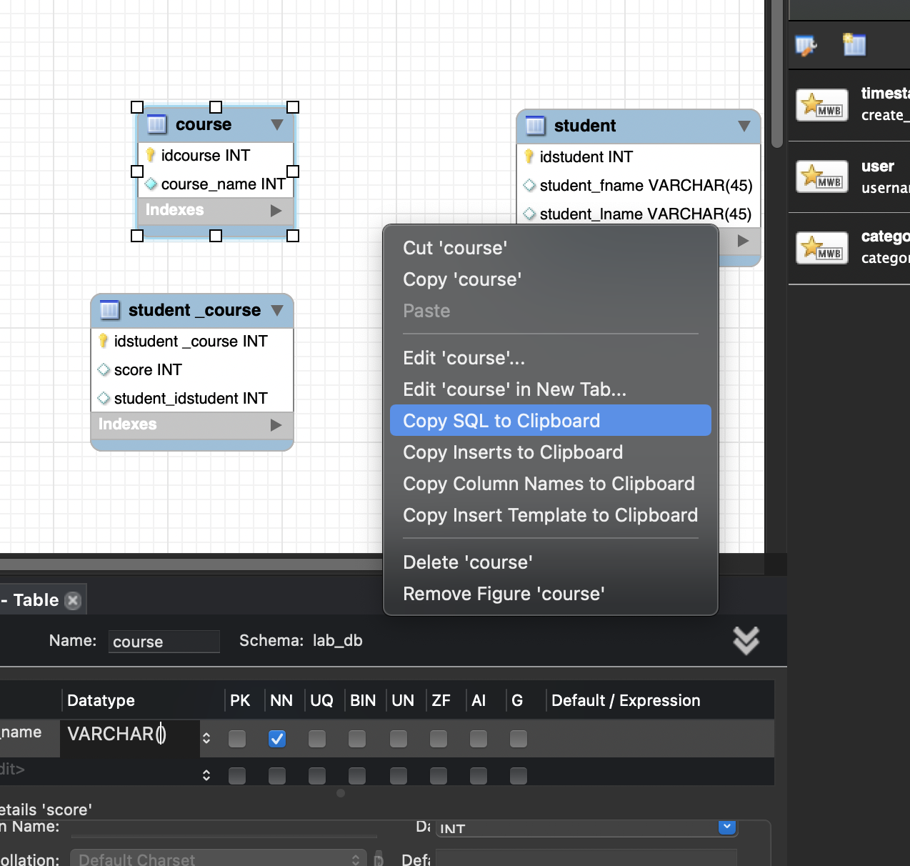
* Copy SQL code directly to the query and it automatically creates the tables and its variables incl. datatypes and relationships (primary Keys etc.)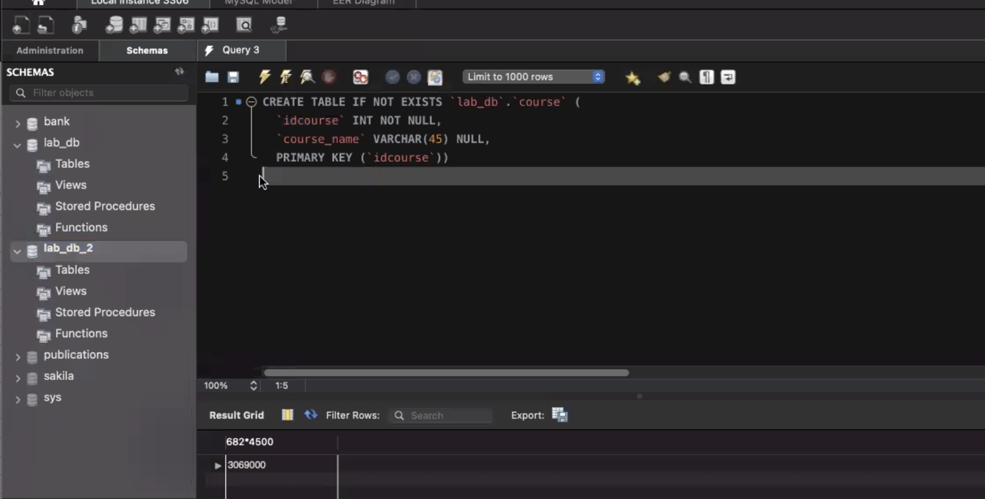

Create Schema (aka Databases)

* Always in utf8mb4 character set & collation utf8mb4_0900_ai_ci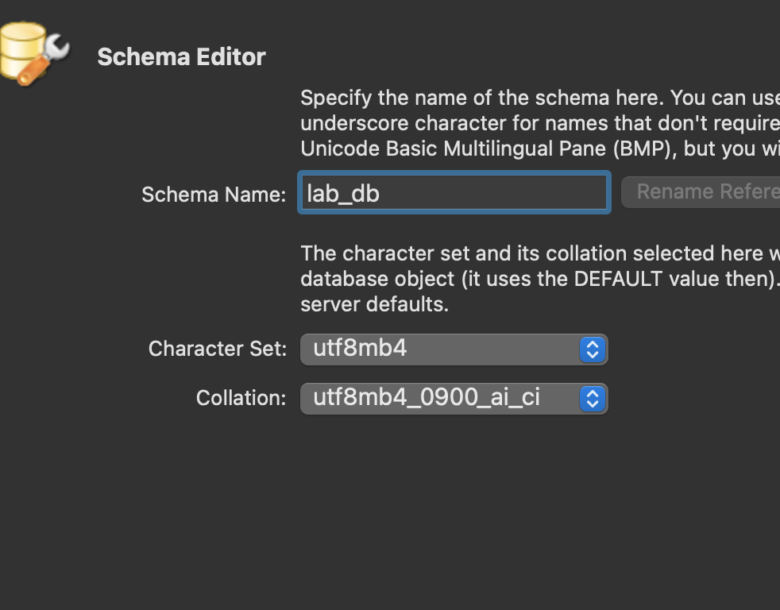

View Schema

* View schema contains queries in view mode (no saving) that can be saved and reused at different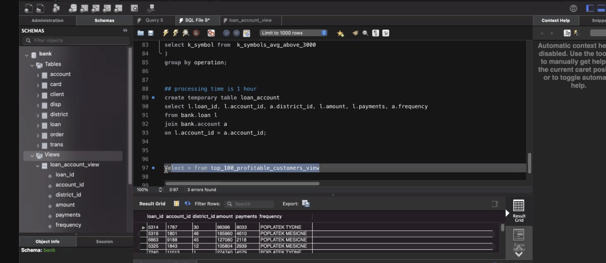 times
* Enables considering (user data) updates (especially with transactional databases)

Create a table

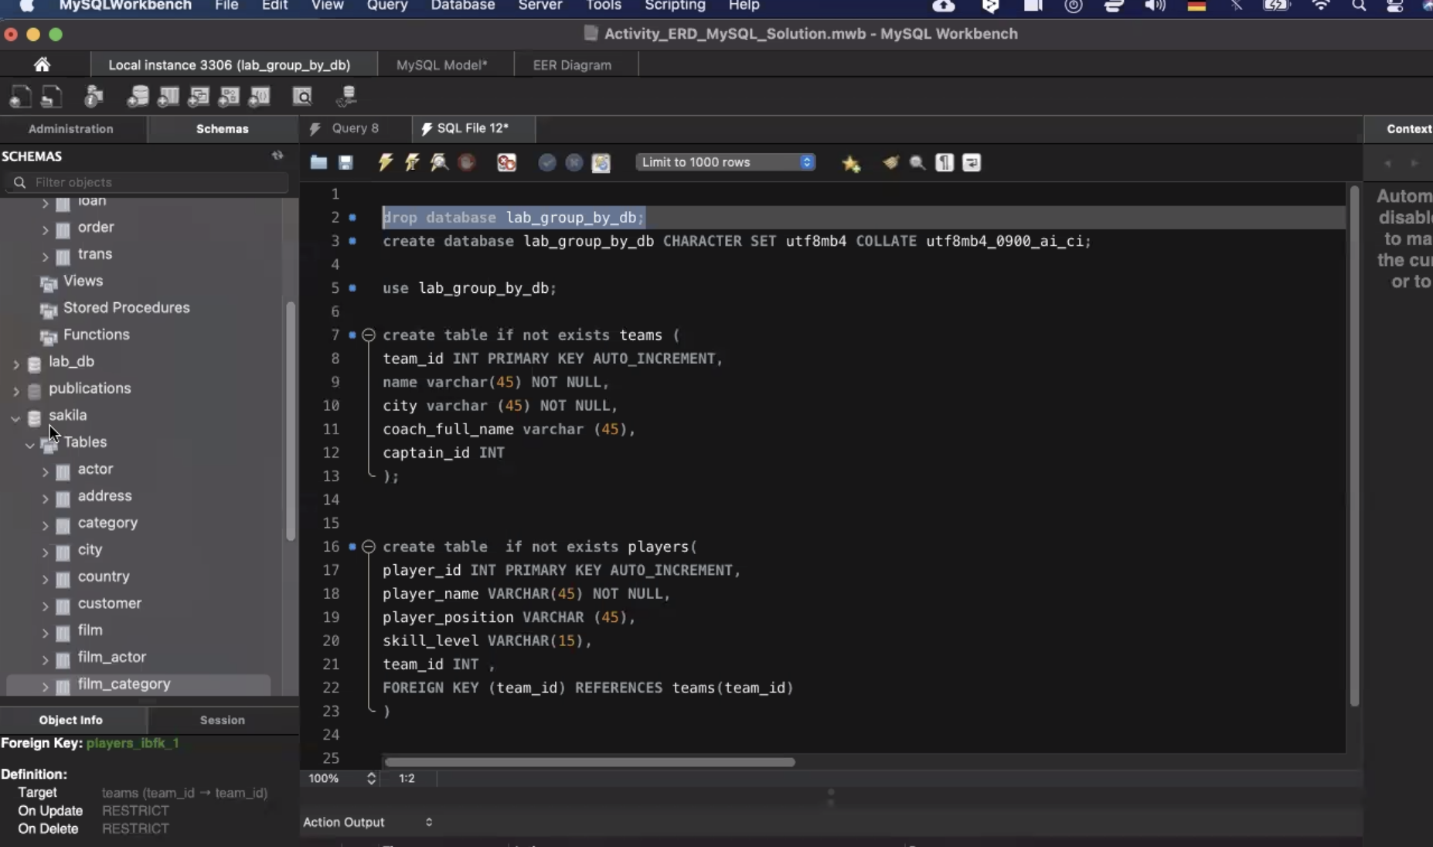

Insert rows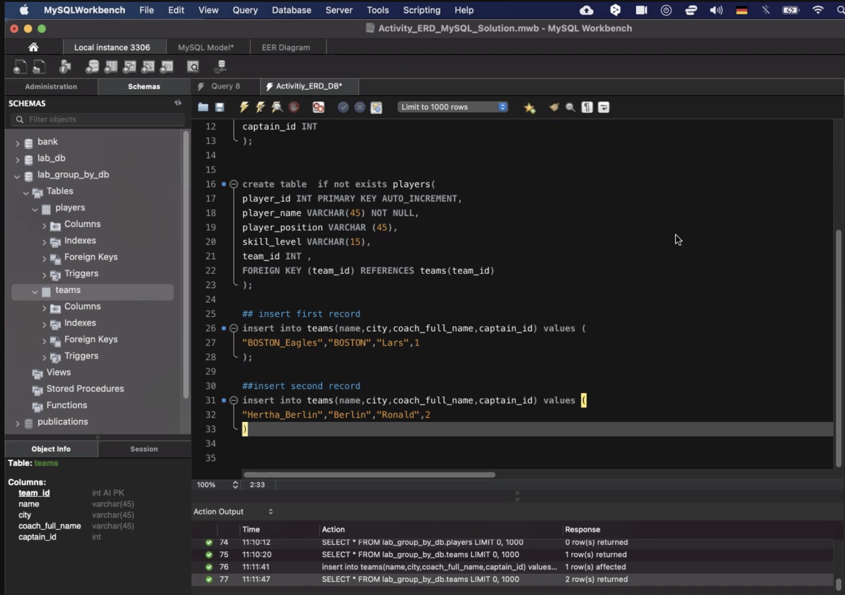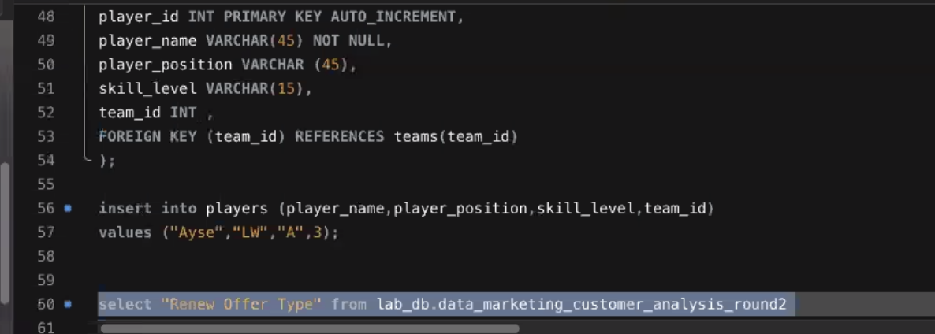

Update a table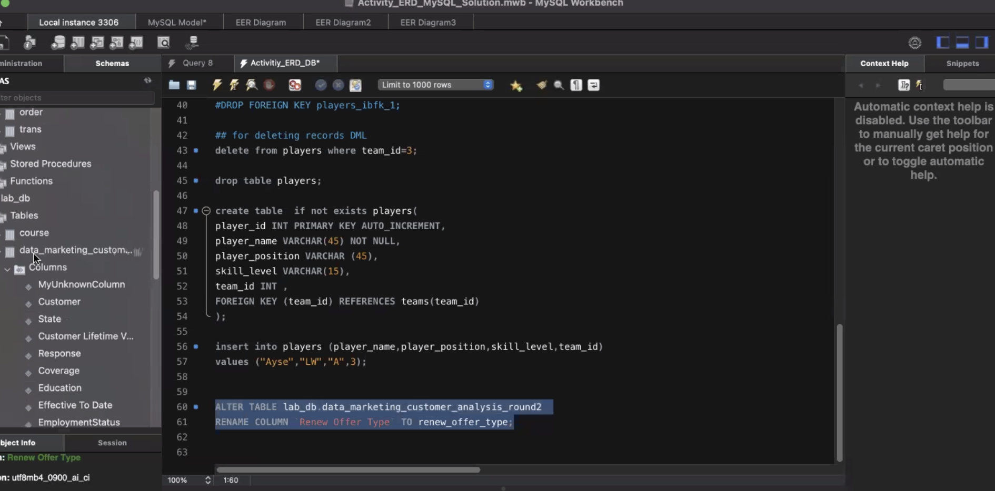

Creating Procedures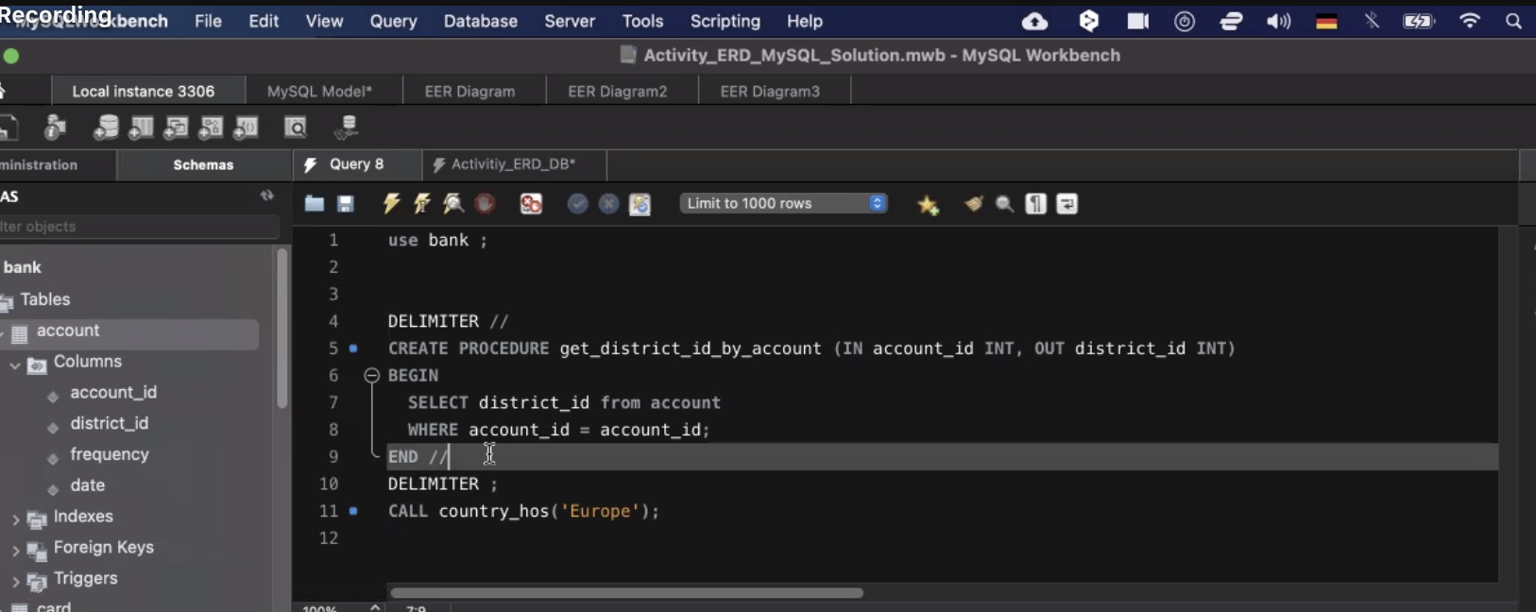

CASE WHEN clause